CLIL lesson plan: ANIMALS

1 A Monkey Puzzle (the picture of a monkey cut into 3)

2 Introducing vocabulary

- pictures of 8 animals, rhymes/the characters of the story (monkey, butterfly, elephant, snake, spider, parrot, frog, bat). Techniques: flashing/slow reveal

- Simon says: walk like an elephant, hiss like a snake, jump like a frog, fly like a butterfly, sleep like a bat (upside down)

- 8-word cards – learners should match them to the flashcards

- characteristic body parts of the 8 animals, separately (on flashcards) – introducing vocab.: tail, wing, trunk, head, web, beak, eyes, ears

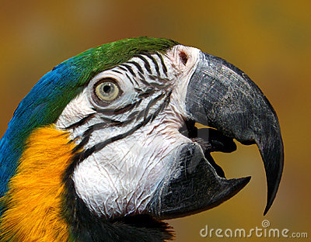
- 8-word cards to be matched to the body parts
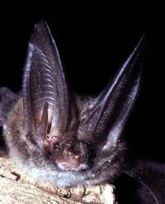
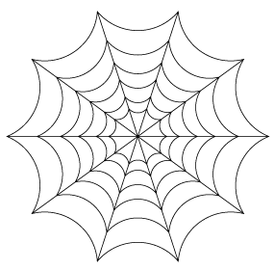
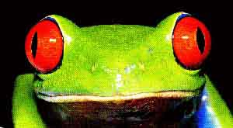
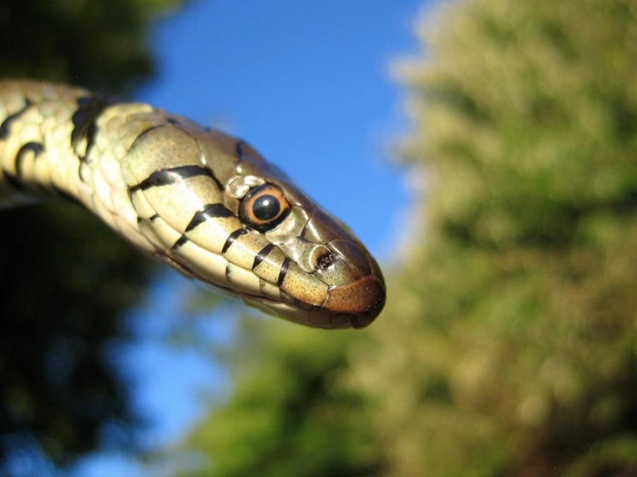


- funny animals: the 8 animal pictures, each with a body part that does not belong to that animal. e.g.: a monkey with a trunk, an elephant with a wing, etc. The task is: to fix, saying: this is the monkey’s tail, this is the elephant’s trunk, etc. A non-linguistic aim: having fun
3 Run and Touch
a) The 8 animal pictures are on board. Teacher calls out descriptions of the 8 animals. Learners line up in two queues. The first two learners compete who can run to the pictures and touch the right one.
The descriptions are as follows:
It’s brown and furry, it has a curly tail.
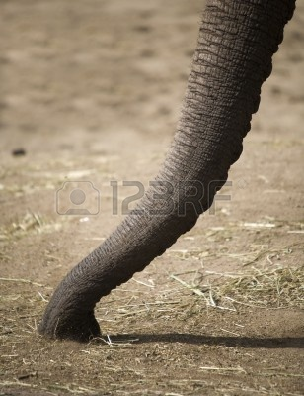
It’s small and has wings. It sleeps all day long.
It has a beak and two wings. It lives in the trees.
It’s long and has no legs. It hisses.
It’s black and hairy. It has a web. It has 8 legs.
It’s small and green. It croaks.
It’s small, colourful and can fly.
It’s very big and grey. It has a trunk.

b) These text cards are to be matched to the animal pictures and word cards
4 Find the rhymes: Separate word cards are on carpet, in random order. Words are taken out of the story. The teacher lifts up one, pronounces the word and calls for a rhyming word. These are the words learners can choose from:

Cry | She | mum | say | fly | wings | Wrong | all | eggs | think
butterfly | Me | come | way | high | springs | Long | small | legs | drink

5 Shared story telling

6 Post-reading task: Name the animals in the book. Which is your favourite character? Why?

7 Self-evaluation. Three faces on the board (smiling, neutral, and sad). Each learner writes his/her name under the emoticon according to how they feel about their contribution to the lesson.

