CLIL lesson plan: AUSTRALIA
- Start: What do you think these pictures have in common?
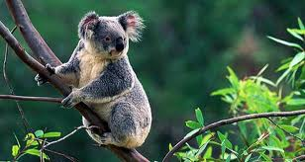

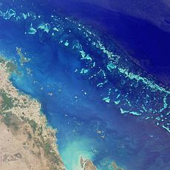

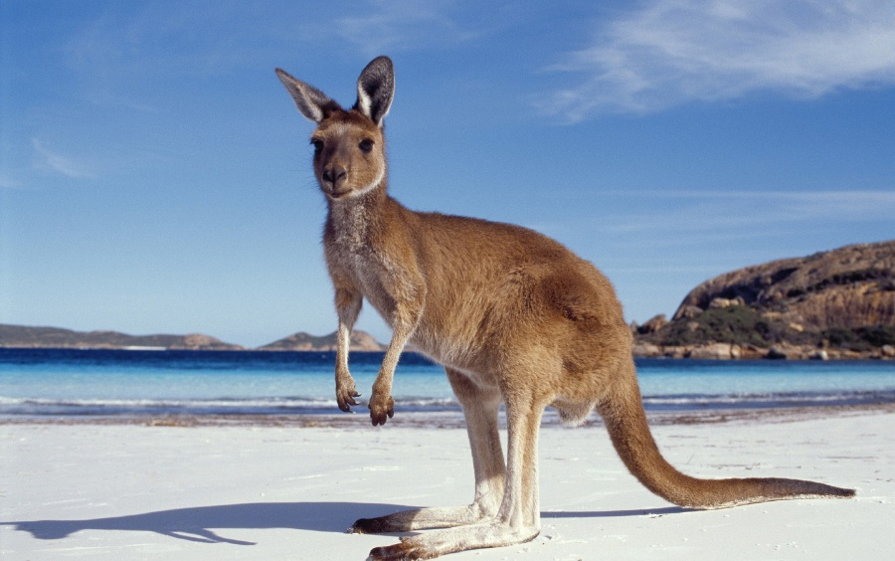
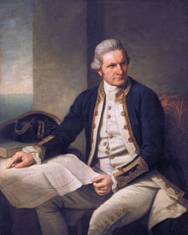
;



- Discuss the pictures. Which one of them do you know?

- Find the captions for each photo, and match them

The Great Barrier Reef | Kangaroo | Sydney Harbour  Bridge | Sydney Opera  House | Koala

- Find Australia on the Globe
- Look at the map of Australia, and answer the questions:

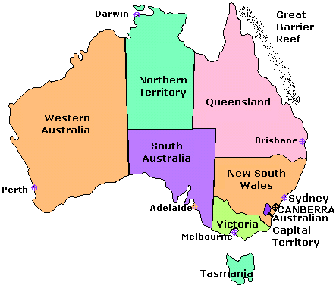

a) How many states does it have? | e) What is the capital city?
b) Which are the two largest states? | f) Where is the Great Barrier Reef?
c) Which is the smallest? | g) What’s the name of the island south of Australia?

Can you think of any other questions? Write them here:
5 Facts about Australia. Do the Australia Quiz. Fill the gaps with one of the words below:

down under, aborigines, United States, outback, sheep, station, pouch, coral, prison, boomerang
Australia Quiz for S
- Australia is called the land ___________________.
- The first people to live in Australia were ___________________.
- Australia is about the size of the ___________________.
- The middle part of the country is called the ___________________.
- Australia has about ten times more ___________________ than people.
- A ranch is known as a ___________________ in Australia.
- A marsupial is an animal that carries its young in a _________________.
- The Great Barrier Reef has the world's largest deposit of ___________________.
- Australia was first used as a ___________________ colony by the English.
- The aborigines used the ___________________ as a weapon.

- Check your answers

- Play the Great Australia Domino game. First match the definitions with the words, then enjoy the game

The first people who lived in Australia long ago | pouch
Sheep’s hair | boomerang
A hunting wooden weapon used by Australian aboriginals | Captain Cook
A typical Australian animal that jumps along its strong hide legs | The Pacific Ocean
A small bag-like formation in which mother kangaroos carry their babies | kangaroo
He discovered Australia | aboriginals
The name of the Ocean around Australia | New Zealand
Australia’s closest neighbour | wool

After having completed the activity, answer the question. In what way do you think information on Australia was delivered? How did it help the learning process?
Draw a mind-map with Australia in the centre. Count the pieces of information you got.
In what way do you think an activity such as the one above might help introduce a new topic?
- My favourite word today has been......

- Self-evaluation with smileys

