Jazz Chants (Youtube)
At the Farm Chant (You Tube) https://www.youtube.com/watch?v=kAaRQKTghw0
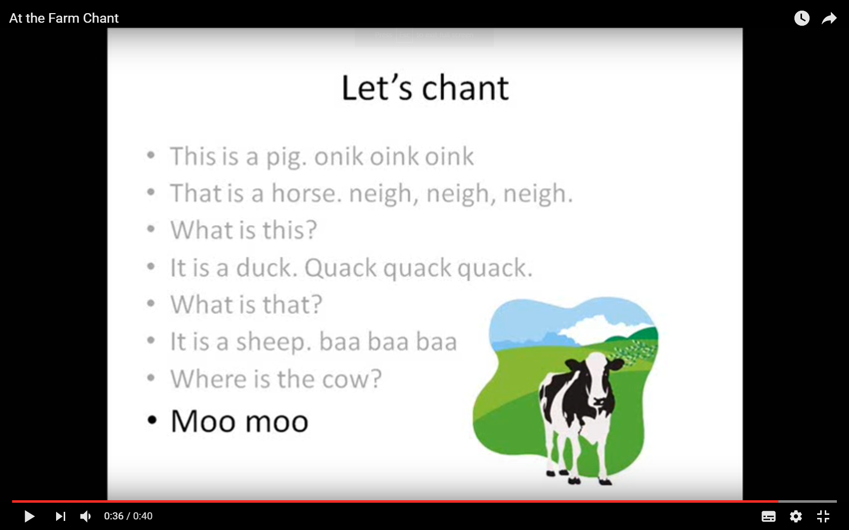
https://www.youtube.com/watch?v=97RDmFzzNlY&index=7&list=PLFB3D4F7DFB5D1C17
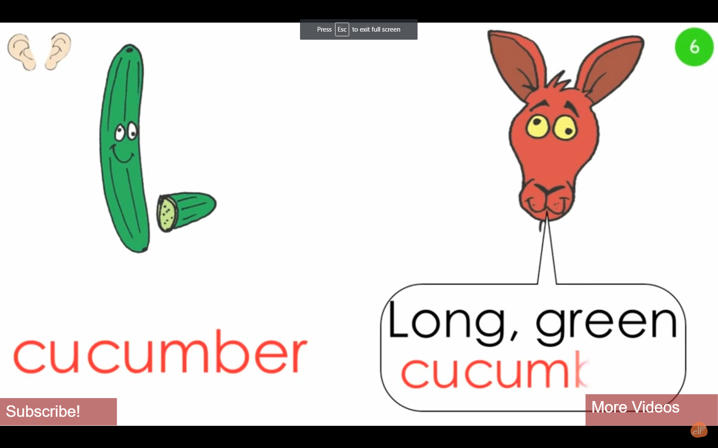
Rhymes for learning English: https://www.youtube.com/watch?v=_KXeq48k_Ao
https://www.youtube.com/watch?v=5UMFa5NcSoI baby sleeping
